Goal: Understand how does the period of the model PNF 1M8 change in the right corner for FCRTR=[0,20] and FCATR=[0,150].

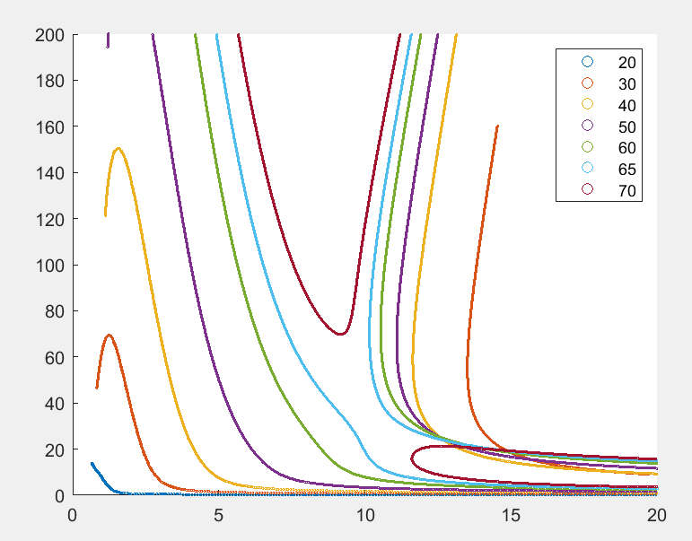

Fig1. Period tracing curves for PNF 1M8 model. X-axis is FCRTR, y-axis is FCATR.

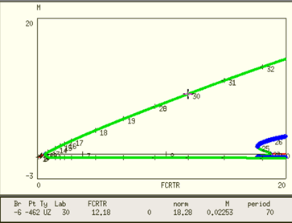

Fig 2. Periodic curves for FCATR=10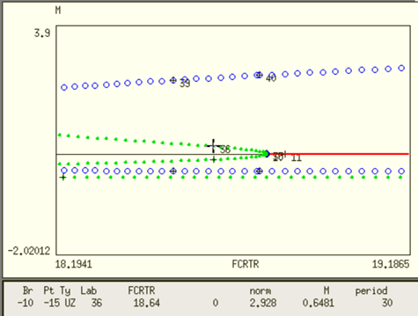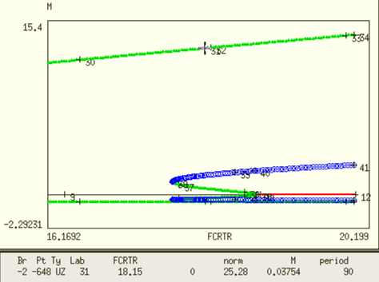

Fig3. Periodic curves and zoom in for the right sub-critical Hopf bifurcation point.

To summarize the questions that we want to answer

There are two stable limit cycles with different amplitude, i.e. small oscillation and large oscillation, in the right corner of Fig1. With the same FCRTR value, there can be different values of period. Which period is located in the small oscillation branch and which period is located in the large oscillation branch?

Procedure: 1-par bifurcation with FCATR=120,80,40,30,20,10 while period tracing T=20,30,40,50,60,70

1. FCATR=120

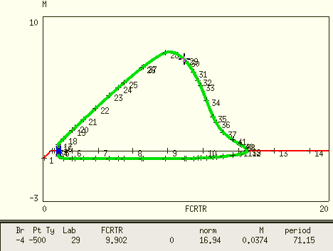

middle region

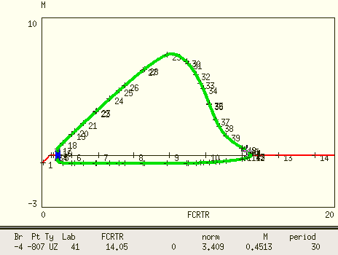

right region

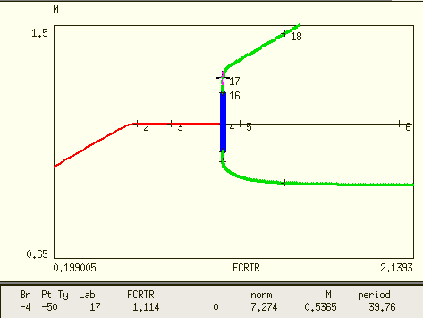

left region

There is only 1 stable limit cycle on the right side, where period is decreasing towards the right corner.

1. FCATR=80

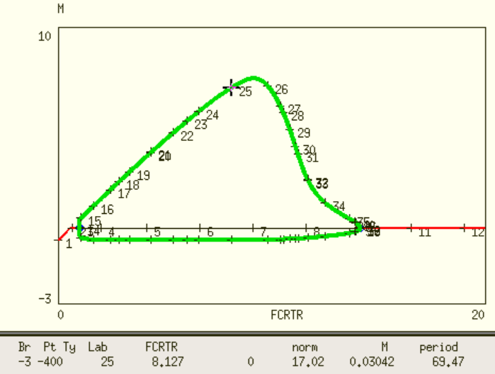

middle region

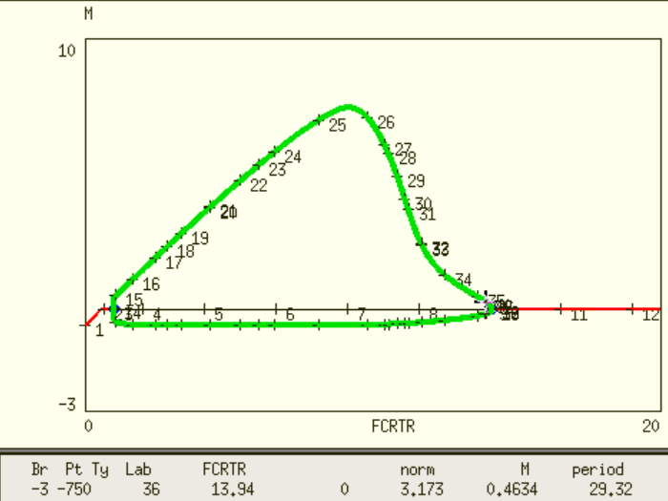

right region

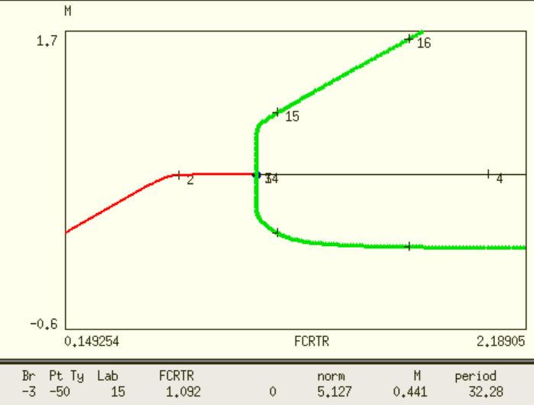

left region

1. FCATR = 40

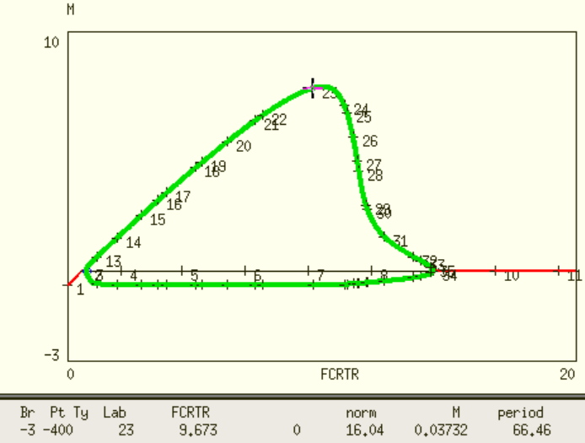

middle region

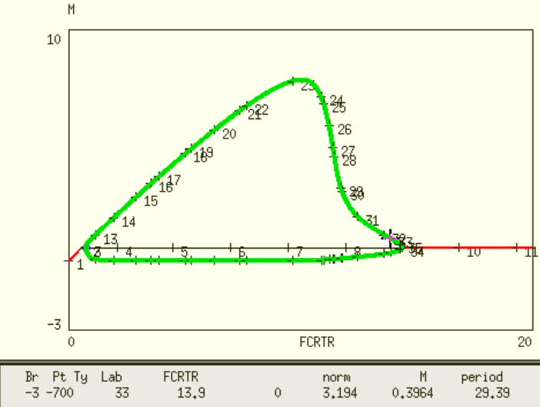

right region

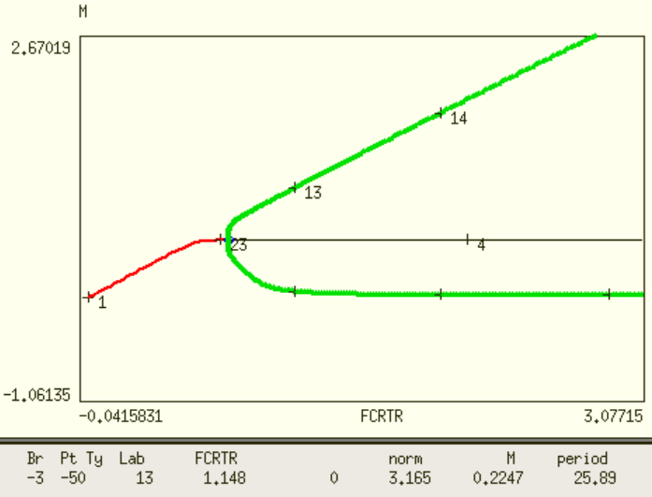

left region

only 1 stable limit cycle

1. FCATR= 30

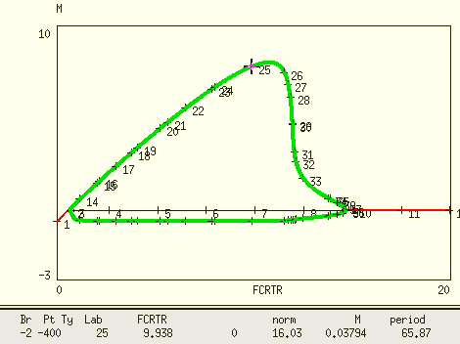

middle region T=65.87 @ FCRTR=9.938

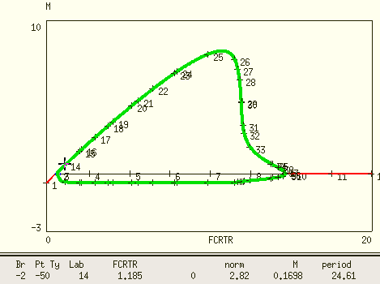

left region T=24.61 @ FCRTR=1.185

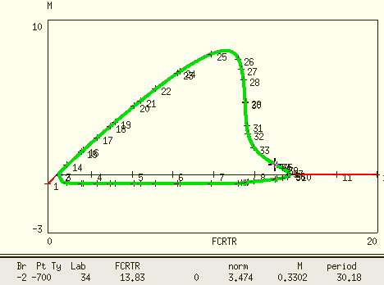

T=30.18 @ FCRTR=13.83

only 1 stable limit cycle

1. FCATR=25

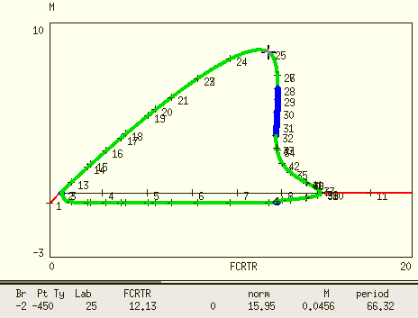

T=66.32 @ FCRTR=12.13

middle region

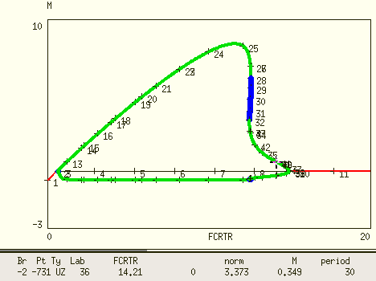

T=30 @ FCRTR=14.21 Right region

Unstable limit cycle (blue points) appears already when FCATR=25. From pt25, whose period T=66, the period decreases smoothly as FCRTR value increases.

1 stable and 1 unstable limit cycle found for FCATR=25

1. FCATR = 23

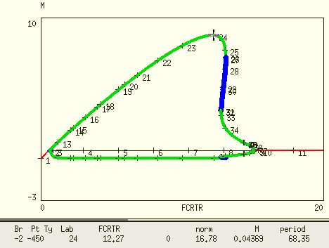

T=68.35 @ FCRTR=12.27 stable limit cycle

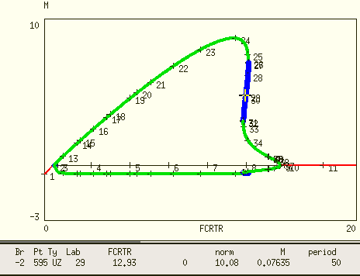

T=50 @ FCRTR=12.93 unstable limit cycle

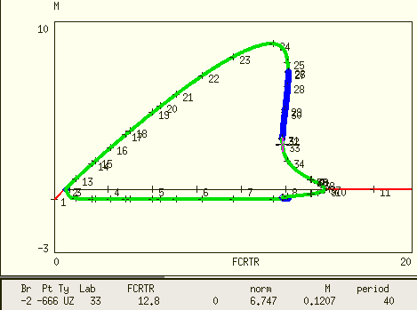

T=40 @ FCRTR=12.8 stable limit cycle with small amplitude

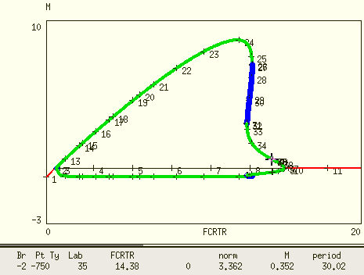

T=30 @ FCRTR=14.38 stable limit cycle

For FCATR=23, period T=50 near the right corner is suspicious because it lies in the unstable limit cycle. I can imagine, when Xpp trace the period with user specified period, it saves the data regardless of the stability of the limit cycle. Therefore, I observe multiple period for the same (FCRTR, FCATR).

1. FCATR = 21

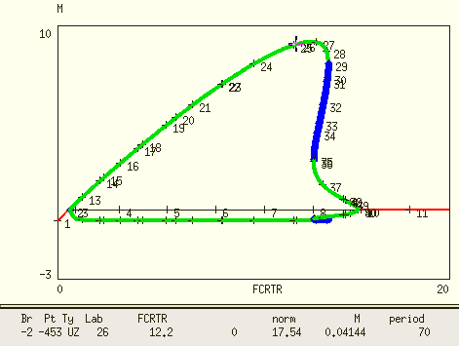

T=70 @ FCRTR=12.2

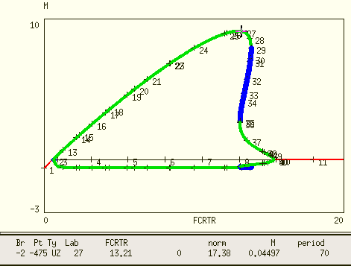

T=70 @ FCRTR=13.21

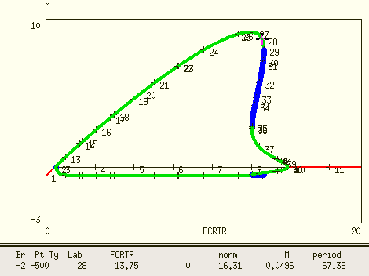

T=67 @ FCRTR=13.75

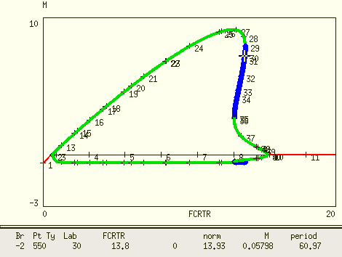

T=60 @ FCRTR=13.8 unstable limit cycle

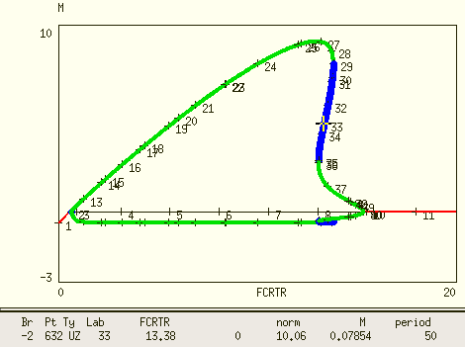

T=50 @ FCRTR=13.38 unstable limit cycle

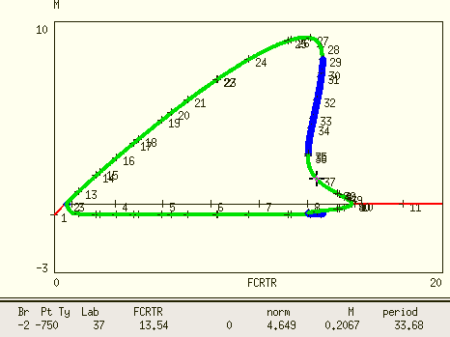

T=33 @ FCRTR=13.54 stable limit cycle

As shown here, a very small variation of FCRTR value can have very different period value and stability of the limit cycle.

1. FCRTR=20

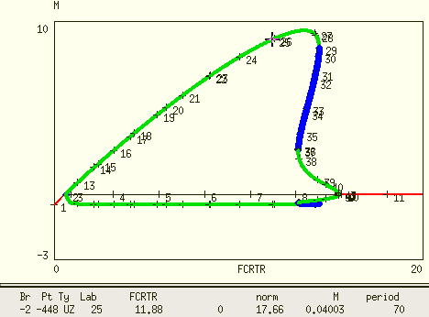

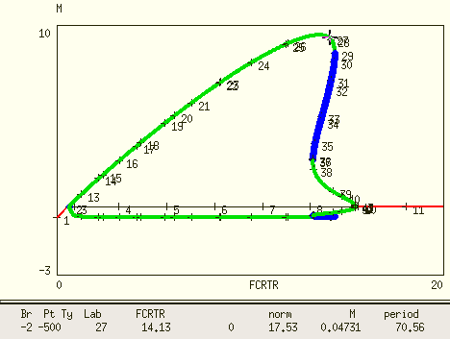

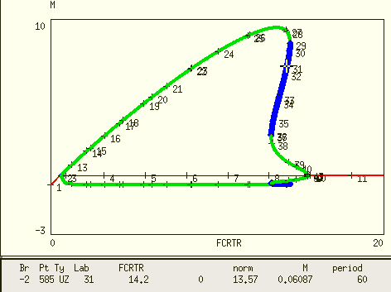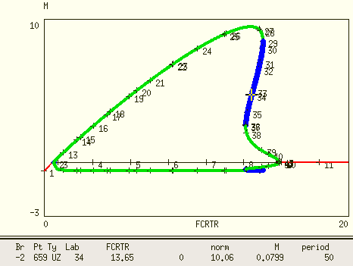

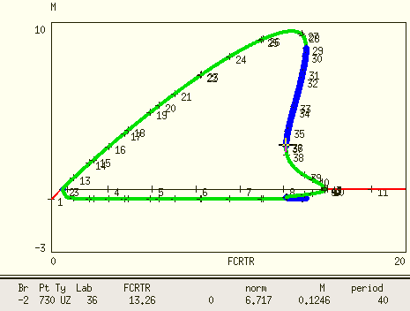

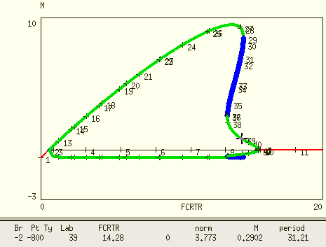

In this case, T=40,50,60 all locate in the unstable limit cycle region.

1. FCATR=15

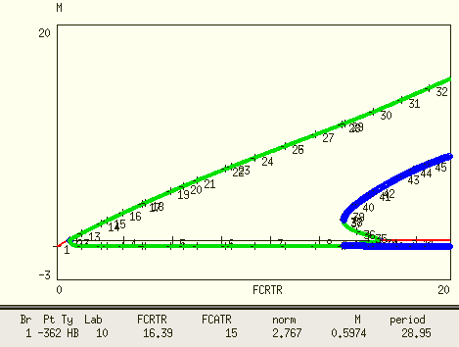

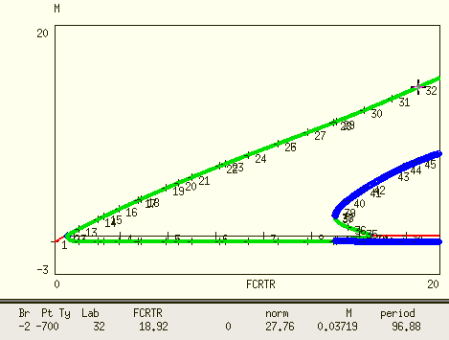

T=96 @ FCRTR =18.92

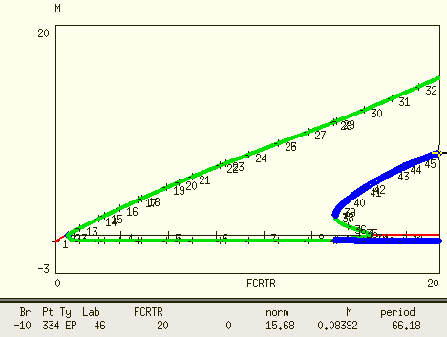

T=66.18 @ FCRTR=20 unstable limit cycle

So in this situation, even T=70 possibly lies in unstable limit cycle (my running stops at FCRTR=20).

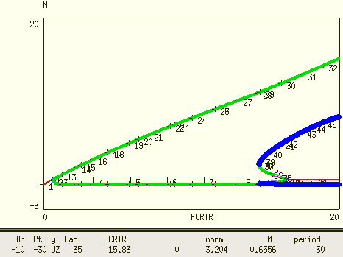

T=30 @ FCRTR=15.83

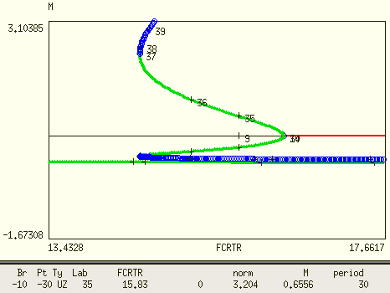

closer zoom in, T=30 lies in stable limit cycle with small amplitude

Summary

I’ve tested 1-par bifurcation with FCATR = 120,80,40,25,23,21,20,15.

1. As FCATR value is large, e.g. >40, there is 1 limit cycle as FCRTR approaches the right HB.
2. As FCATR goes below ~25, an unstable limit cycle appears
3. As the shape of the periodic curve shown for FCATR=25 and FCATR=20 (beginning of this memo) suggests, small period e.g. T=30 always lie near the 2nd HB with small amplitude.
4. I think for FCATR <25, where the unstable limit cycle (blue dots) begin to twist and there are 2 period values for a single FCRTR value near the 2nd HB.
5. As FCATR value becomes small, the period of stable limit cycle with large amplitude near the right corner of (FCRTR, FCATR) plane will go up. The T=70 period curves in the beginning should correspond to an unstable limit cycle at certain value of FCATR.
6. Lastly, my period tracing curves generated does not tell me whether the limit cycle is stable or not. Xpp original data for my testing above should contain information about this, but I wasn’t able to figure it out (For different types of points, Xpp seems to have different code, e.g. screenshot below). If that is possible, I can probably filter out the period tracing data by only using period corresponding to stable limit cycle?

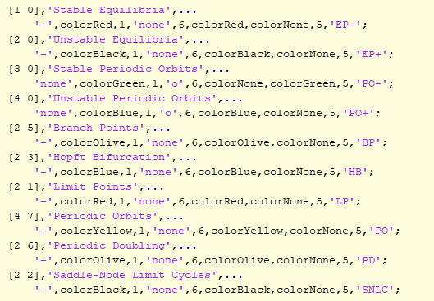

(this is from 3rd party code I found for plotting Xpp data in MATLAB)

1. Back to the task of plotting the period color map of Fig5 1M8, the right corner is a hot spot where complexity appears. But it is safe to say period T=30 there always corresponds to stable limit cycle with small amplitude.

Update:

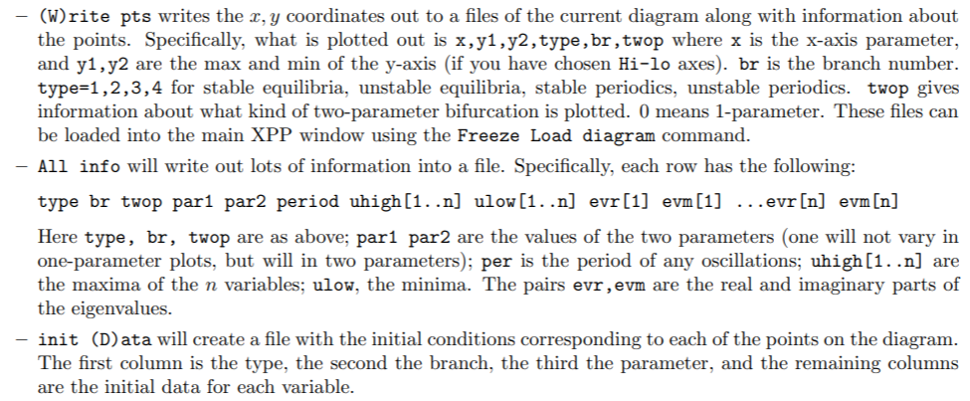

Document of the output file format in Auto.

Although stability of points is reported in “allinfo” dat file from Xpp for 1-par bifurcation, this information is not reported for points calculated from period tracing.The figure below shows the period tracing for T=60 with FCATR=21

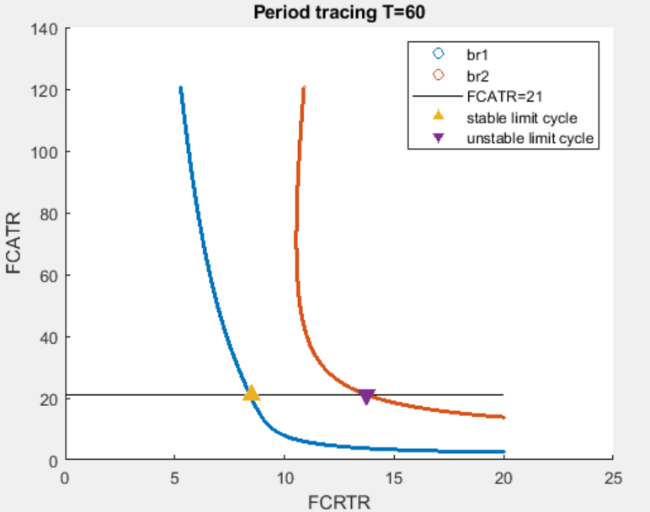

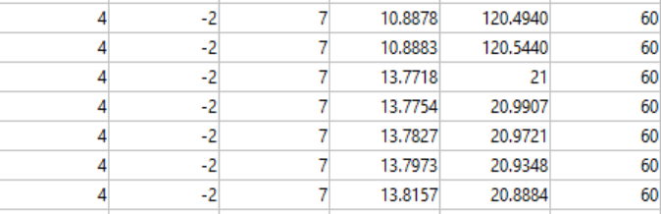

This is the “allinfo” output dat file, its “type” is 4, “twop” is 7.

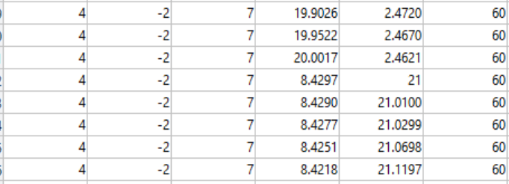

For another point, there is no difference. The “type” is 4.

However, based on my testing, the left point @ FCRTR=8.43 and FCATR=21 should correspond to stable limit cycle as shown below.

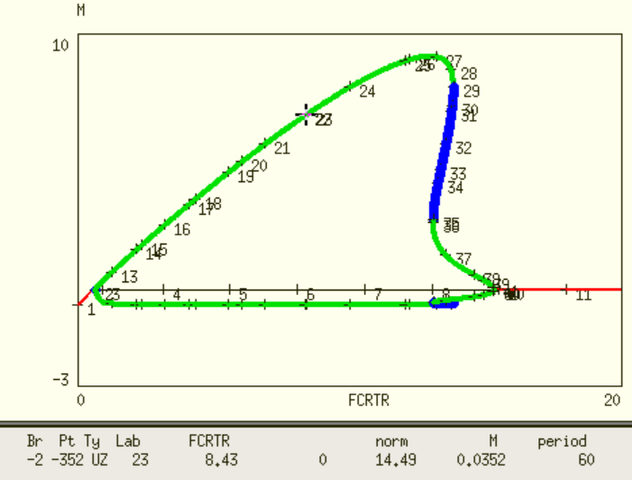

Therefore, in period tracing with user specified period value. The stability information is not available.



[4 7] only tells me this point lies on a periodic orbits without information about its stability.